|  |  |
| --- | --- |
| **[Assignment / Project] – External Document** |  |
| BZ01-LAB  LAB HCI |
| [Even] Semester Year 2020/2021 |

* Project Title

DanBam Website

* Introduction

Kami beranggotakan 3 orang imgin membuat website danbam dengan tema neon pastel. Disini kami membuat 5 web yaitu Homepage, Menu, Location, Contact Us, dan About Us. Pengumpulan tugas projek ini yaitu 18 Juni 2021.

* Report / Documentation

1. 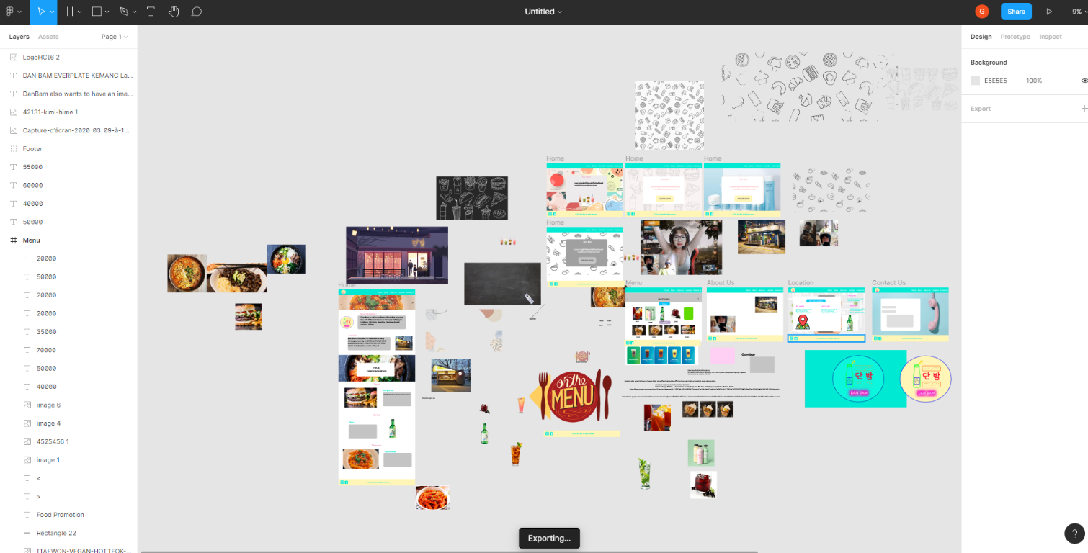Full Wireframe
2. Logo

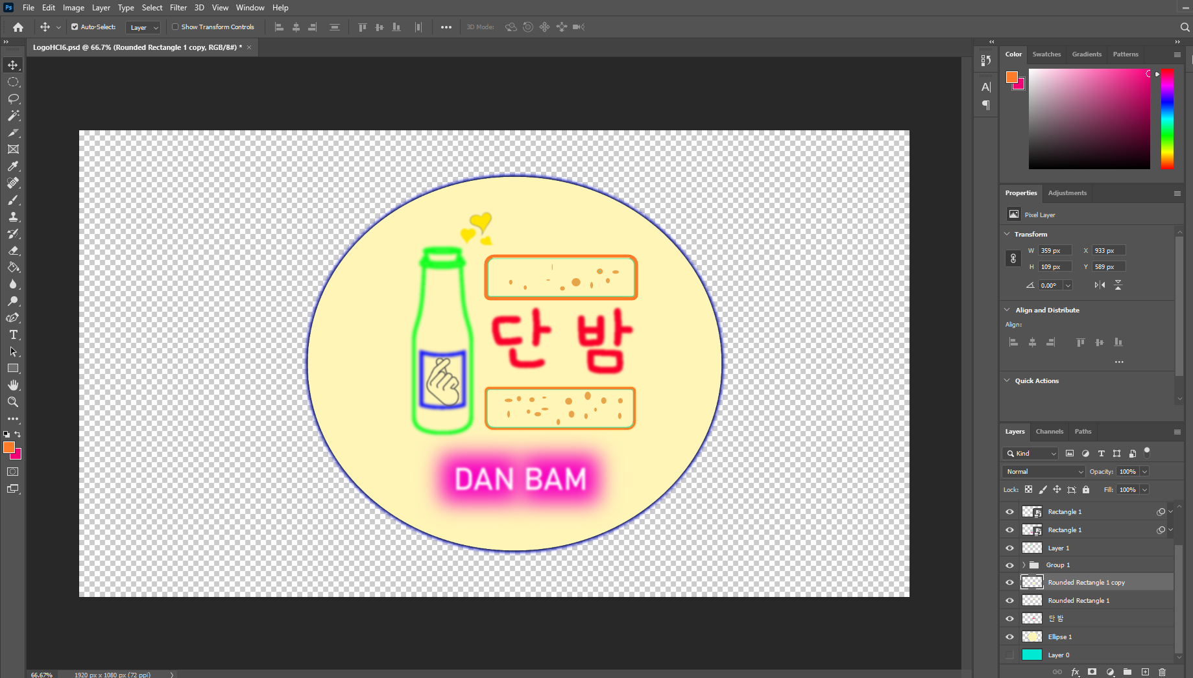

1. Homepage

1. Report

* Anggota melakukan pembagian tugas yang telah disepakati pada tanggal 9 Juni 2021 dan sudah mulai dikerjakan
* Pembuatan Logo yaitu pada tanggal 10 Juni 2021
* Pembuatan Wireframe keseluruhan pada tanggal 11 Juni 2021
* Pembuatan Homepage di photoshop pada tanggal 11 Juni 2021
* Perancangan web 12 – 15 Juni 2021
* Finishing web pada tanggal 16-17 Juni 2021
* Pengumpulan web pada tanggal 18 Juni 2021
* Anggota berdiskusi dengan via line dan discord
* Reference

- Rice Box Menu:https://www.danbamofficial.com/wp-content/uploads/2020/12/Kimchi-Bokkeumbap-%EA%B9%80%EC%B9%98-%EB%B3%B6%EC%9D%8C%EB%B0%A5-Fried-Rice-300x300.jpg

- Japachae Menu: https://www.danbamofficial.com/wp-content/uploads/2020/12/ITAEWON-JAPCHAE-%EC%9E%A1%EC%B1%84-1-300x300.jpg

- Hotteok Menu: https://www.danbamofficial.com/wp-content/uploads/2020/12/ITAEWON-VEGAN-HOTTEOK-%ED%98%B8%EB%96%A1-CHEESE-300x300.jpg

- Burger Menu: https://d38trduahtodj3.cloudfront.net/images.ashx?t=ig&rid=VisitLaredo&i=pino_burgers.jpg

- Toppoki Menu: https://th.bing.com/th/id/R5bda4679e7d9dafb748cd7d39044332a?rik=sdeIwoQD5PGXfw&riu=http%3a%2f%2fwww.koreadepart.com%2fdata%2fcheditor4%2f1610%2f574f07069f33e344e09c0d51a377daa7_YpUa5fda4cJAXl.jpg&ehk=CfzIDh%2fmn37vsh8wG1hvFjfnpA%2bFEBQJg%2bzq9bh6pik%3d&risl=&pid=ImgRaw

- Brownies Menu: https://www.texanerin.com/content/uploads/2018/12/gingerbread-brownies-7.jpg

- Pancake Menu: https://awsimages.detik.net.id/community/media/visual/2020/11/04/croffle.jpeg?w=1280

- Danbam Banner: https://i.pinimg.com/originals/98/02/d8/9802d8a04e78c8ae3fdea7e02ec50511.jpg

- Danbam foto About Us: https://www.koreaetour.com/wp-content/uploads/2020/03/Capture-d%E2%80%99%C3%A9cran-2020-03-09-%C3%A0-10.03.07.png

- Hotteok Image Slider: https://upload.wikimedia.org/wikipedia/commons/9/97/Hotteok.jpg

- Burger Image Slider: https://d1ralsognjng37.cloudfront.net/8db415d2-4884-4149-90eb-b81e439b89f5.jpeg

- Soju Image SLider: https://th.bing.com/th/id/OIP.Y9A_YTlLjDbng239c70mVgHaE7?pid=ImgDet&rs=1

- Brownies Image Slider: https://th.bing.com/th/id/Rbfb88ead7173b1d571e911fa081f34c6?rik=piz4oEihXNiXIw&riu=http%3a%2f%2fwww.cupcakeproject.com%2fwp-content%2fuploads%2f2018%2f04%2fCakey-Brownies-02.jpg&ehk=%2bYw6NzwWJhUn9nJNQMklaBrCEw9uV0S6QDKhO8cJXN0%3d&risl=&pid=ImgRaw

- Google Maps Logo: http://127.0.0.1:5500/assets/main/location/map.png

- Toppoki Home: https://2.bp.blogspot.com/-zGGimuTATwc/WucRRcRo5gI/AAAAAAAAAOs/tBtdKwrXknIaVu-qthr_oq7sWBaZxSd3wCLcBGAs/s1600/main.jpg

- BlackCurrant Menu: https://th.bing.com/th/id/OIP.8KJGS0whoBP3236csrSY_AHaIp?pid=ImgDet&rs=1

- Lemon Tea Menu: <https://www.anniesnoms.com/wp-content/uploads/2019/06/lemon-iced-tea-6.jpg>

-https://www.freepik.com/free-photo/yogurt-with-chia-seed-berries-glasses_7498210.htm#page=2&query=dessert&position=19

-https://cdn.leitesculinaria.com/wp-content/uploads/fly-images/108891/bibimbap-recipe-1200x900-c.jpg.optimal.jpg

* Group Member
* 2440042014 - Faris Adilah Zakaria
* 2440017706 – Ronaldus Priambudi Sebleku
* 2440013765 - Geraldy Kumara